Free

Flu Vaccine CLinic

**DATE: Tuesday October 15th, 2024**

**TIME: 3:00PM – 6:30PM**

**LOCATION: Mitchell Corn Palace**

**For all children 6 months through 18 years of age and adults under the age of 65.**

**\***CDC Recommends that adults aged 65 and older receive High-Dose inactivated influenza vaccine. The high-dose vaccine is not available at this clinic. **\***

**Please register each participant using the QR code or weblink below prior to the event.**

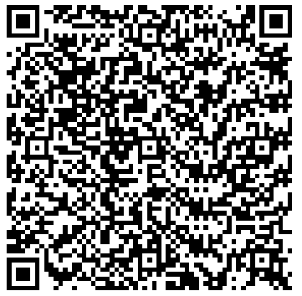

<https://my.primary.health/l/mitchell_pod>